

electronic Customs management system
User Guide

On

Declaration- aPPROVAL

Version: 1.0
Date: 05/09/2022

About Yang Khor Pvt Ltd

Yang Khor IT Solutions is a leading In-country Technology Solutions Provider providing solution in terms of hardware, software, support, and services as its complete package.
Yang Khor IT Solutions has been serving its purpose since 2005, it now has emerged to be an unprecedented leader as a Solution Integrator with a differentiated vertical approach to providing innovative solutions. Yang Khor uses its solution integration capabilities to integrate best-of-breed products through its key technology alliance partners to provide “End to End” solutions. Provide customized business solutions that help organizations accelerate revenue growth, increase market penetration, optimize operating costs and improve employee productivity, by embedding communication in their business processes.

Yang Khor IT Solutions has achieved to be the Gold Partner of HPE, Service One Partner of HPE, Microsoft Silver Partner and VMWARE Professional Partner and having this Partnership we are able to serve the best of solution to our clients. Yang Khor IT Solution initially focuses on providing the best solution in terms of hardware and software, to serve the purpose of making life better with the Advance Technology which the world is moving forward with.

DOCUMENT HISTORY
S.No | Date | Version. No | Description | Approved By
1 | 05/09/2022 | 1.0 | First Release

Contents
Chapter 1- About This Guide 4
Purpose and Audience 4
Document Conventions 4
Chapter 2- Getting Started 5
End-user experience of the self-service process 5
1. Logging In 5
1.1. Forgot/Reset password? 6
Chapter 3- Approve International Transit Declaration. 9
Declaration Approval 10
Approve Dispatch Challen 14
Release Order 15
Release Cargo 16
Get Out Dispatch Challan 18
Get In Dispatch Challan 20
Payment 22
Pending Payment 23
Valuation 25
Centralized Risk 26
Release Order 27
Release Cargo 28

Chapter 1- About This Guide
Welcome to the Trade Facilitation Baseline Customs Management System (eCMS) user guide for CFA USER! This user guide aims to enumerate the process and steps involved in using eCMS.
This user guide is divided into different topics and sub-topics. Each topic discusses and shows the steps of the modules that the eCMS.

Purpose and Audience
This user guide will help the user to get a quick reference on usage of the system.

Document Conventions
Refer to this section to familiarise yourself with the visual aids used throughout the user guide.
Navigation
To assist you with accessing screens, pages, or windows, refer to the following navigation format:
Click User Registration>>Users
Buttons, fields, and other system elements
All system elements are highlighted in Bold text.
Hyperlinks
All topics mentioned in the user guide’s content are hyperlinked. Click on the hyperlink to view the referenced topic.
Callouts
Callouts are presented differently from the original CONTENTS and highlight certain information.
There are two types of callouts: tips and warnings.

@ | A Tip provides useful information that helps you complete a task or procedure.

! | A Warning refers to information that may be critical to the system’s functionality and might affect data or system stability.

Chapter 2- Getting Started
Refer to this chapter to familiarize yourself with the eCMS System; how to log in, Approve Exemption, and log off from the system.

End-user experience of the self-service process

Logging In
To log in to the eCMS:
- Type in URL http://uat.ecms.gov.bt/ECMS/login/indexBhutan.jsp in your Internet browser to access the eCMS System.
- eCMS Front End landing page will display as below,

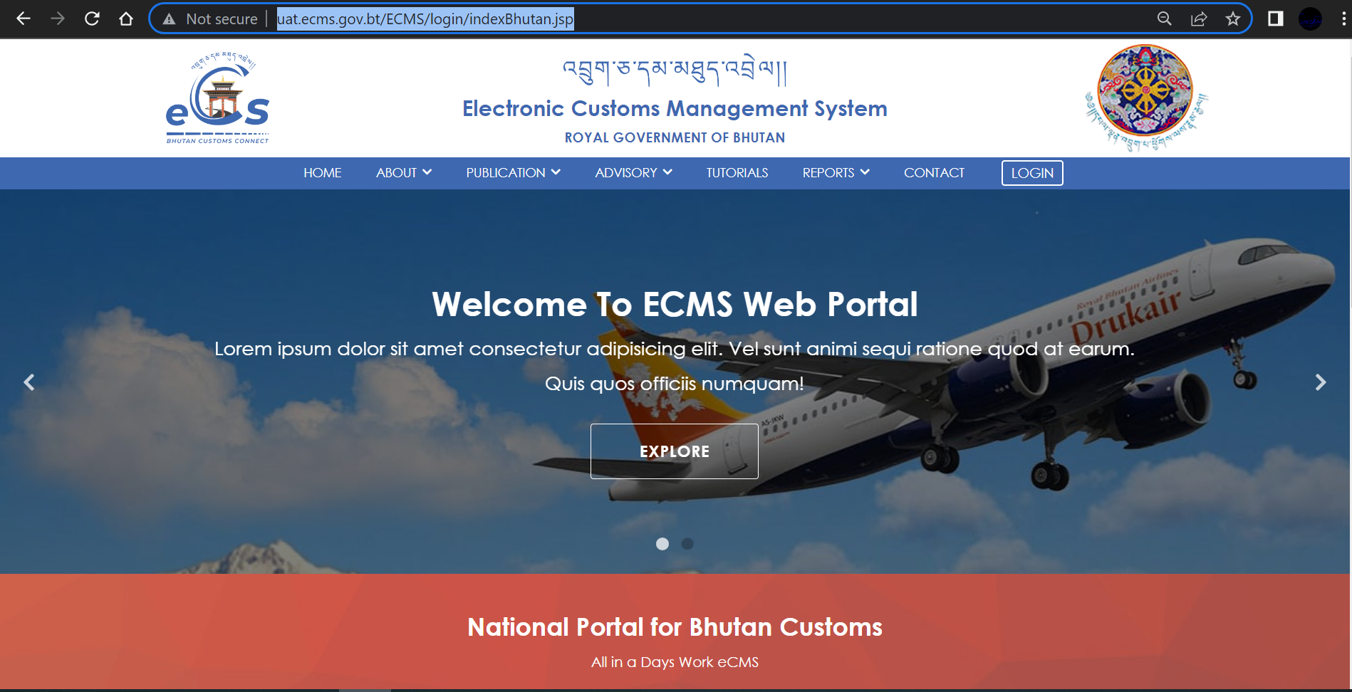

Fig.1. eCMS Landing page

- Click>>> LOGIN available on the top right corner of the landing page

  - Click >>LOGIN, the following login screen (Figure 2) is displayed

eCMS Login

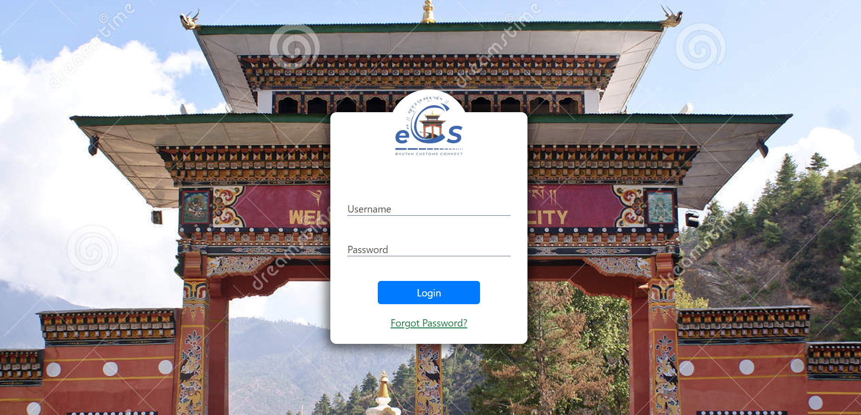
fig.2. eCMS login Page

  - Enter the USERNAME and the PASSWORD in the fields provided and Click button.

@ | In case you need to reset or forgot your password, On the login page, the user clicks the Forgot Password? link to start the process. The new password will be sent to your registered email.

Forgot/Reset password?
- If User Password is expired or forgot , Click >>“Forgot Password?”, “Forgot password Form” is displayed as shown in the figure 3 above.

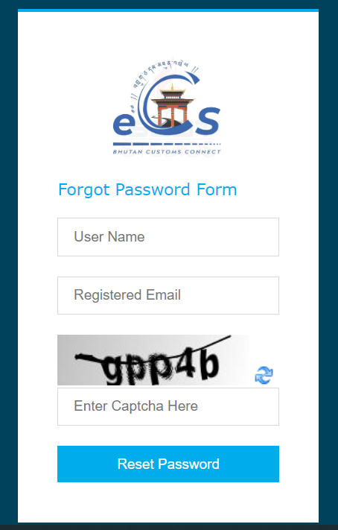
Fig.2. Forgot Password Form.
- Fill in the required details “User Name”, “Registered Email”, “Enter Captcha” and click on “Reset Password” Buttom. The subsequent screen is displayed;
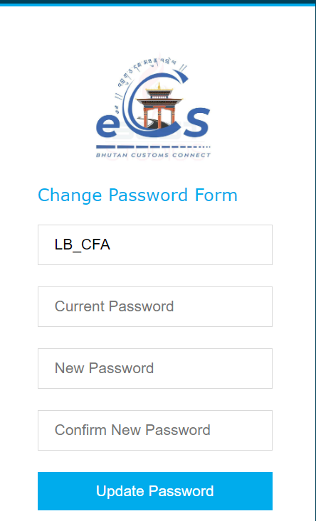
Fig.3. Update password

- Check your email for the password provided by the system and input in “Current Password” Field.
- Set your New Password and Confirm New Password.

- Click >> Update Password, the initial login page is displayed as below;

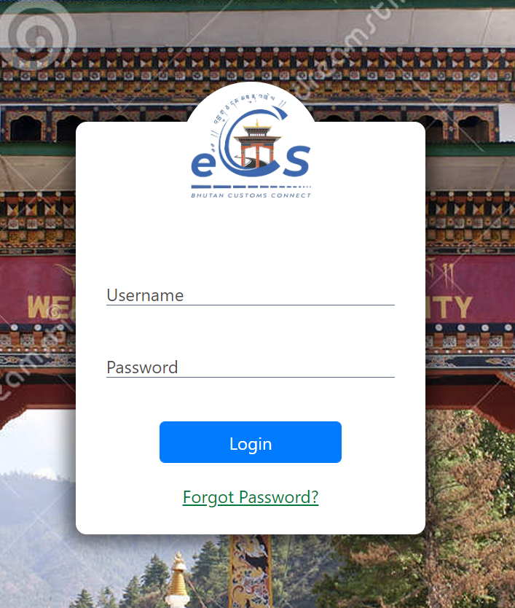
Fig.4. eCMS Login Page
- Enter the USERNAME and the NEW PASSWORD in the fields provided and Click “LOGIN” button.

Click>> LOGIN

- Upon successful login the Electronic Customs Management System Home Page will be displayed as shown below.
Dashboard Page

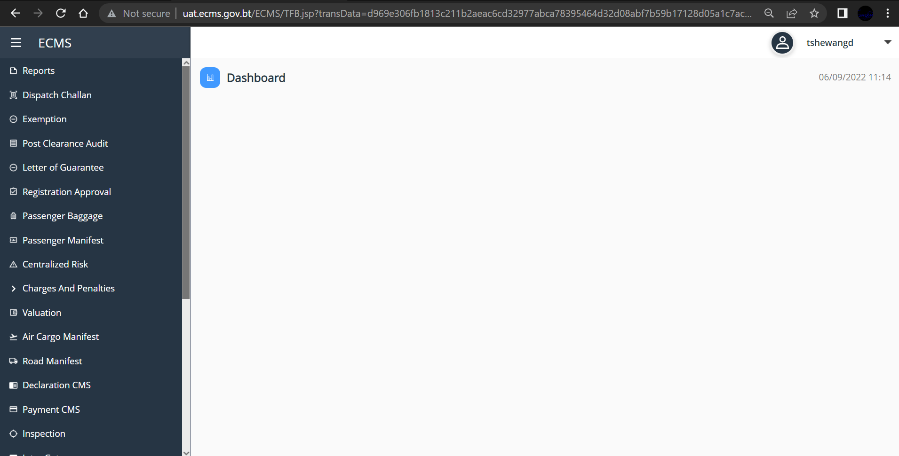
Fig.5. eCMS Dashboard (CFA)

Chapter 3- Approve National Transit Declaration.

Declaration Approval
- Go to Declaration menu and click on “Approve Declaration”. Subsequent Screen is displayed with the list of Declaration in the dashboard. Pending Declaration list are listed under “PENDING ACCEPTANCE DECLARATION”
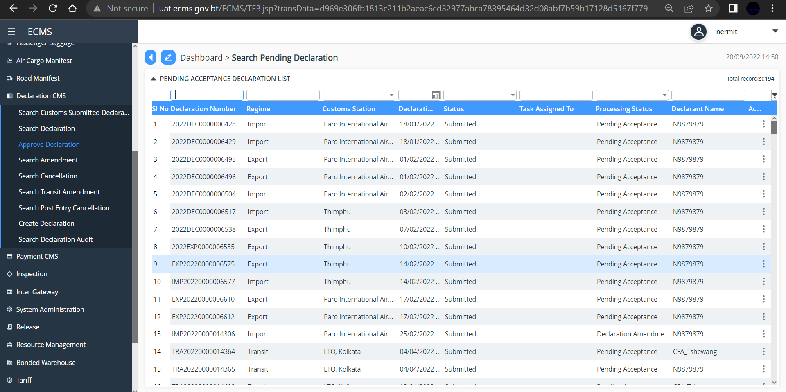
Fig.6. Approve Declaration Dashboard
@ | - You can track/search the Declaration with Declaration number/Regime/Customs Station/Date of Application/Status/Task assigned to/Processing Status/Declarant name/Action.
- Click on the Declaration to view details. The details can be view as below.

- General Information
Click each declaration list to view the details. Under General Information, following information are displayed
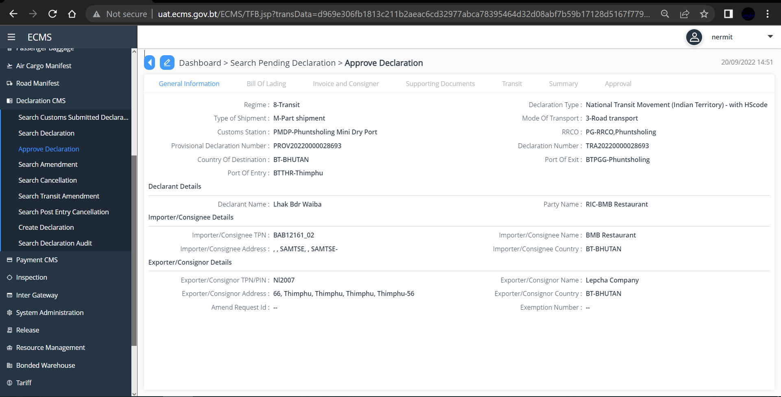
Fig.7. General Information
- Click>> Bill of lading,
for single shipment, there will be only one Bill of Lading. For Part Shipment, Bill of Lading is two or more as below, there are two Bill of lading as the shipment was for part Shipment.
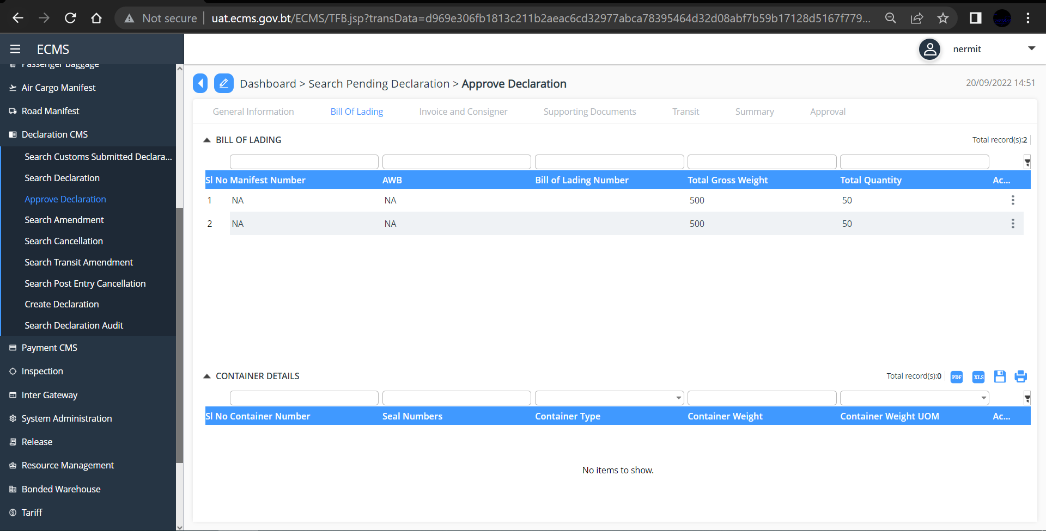
Fig.8. Bill of ladin
- Invoice and Consignor
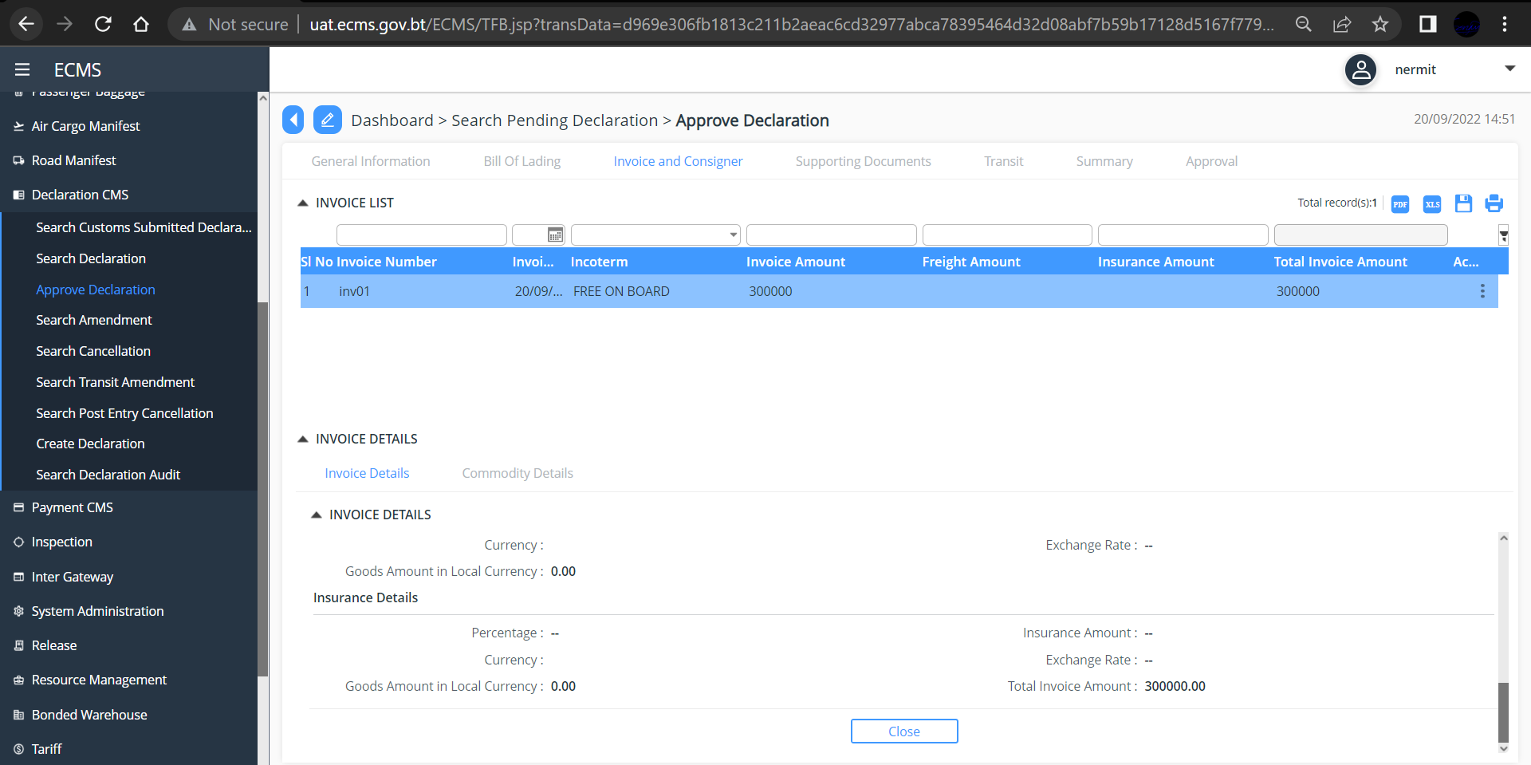
- Click>> Supporting Document
- Click on the three dots available at the right end of the supporting document to view the details.
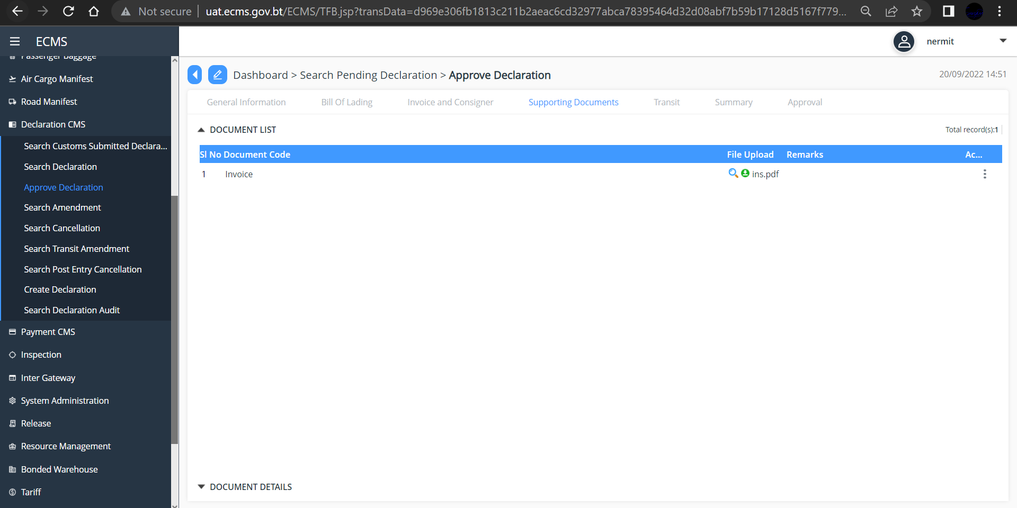
Fig.9.View supporting Document

- Transit Details
Click on the “Transit” to view transit details.
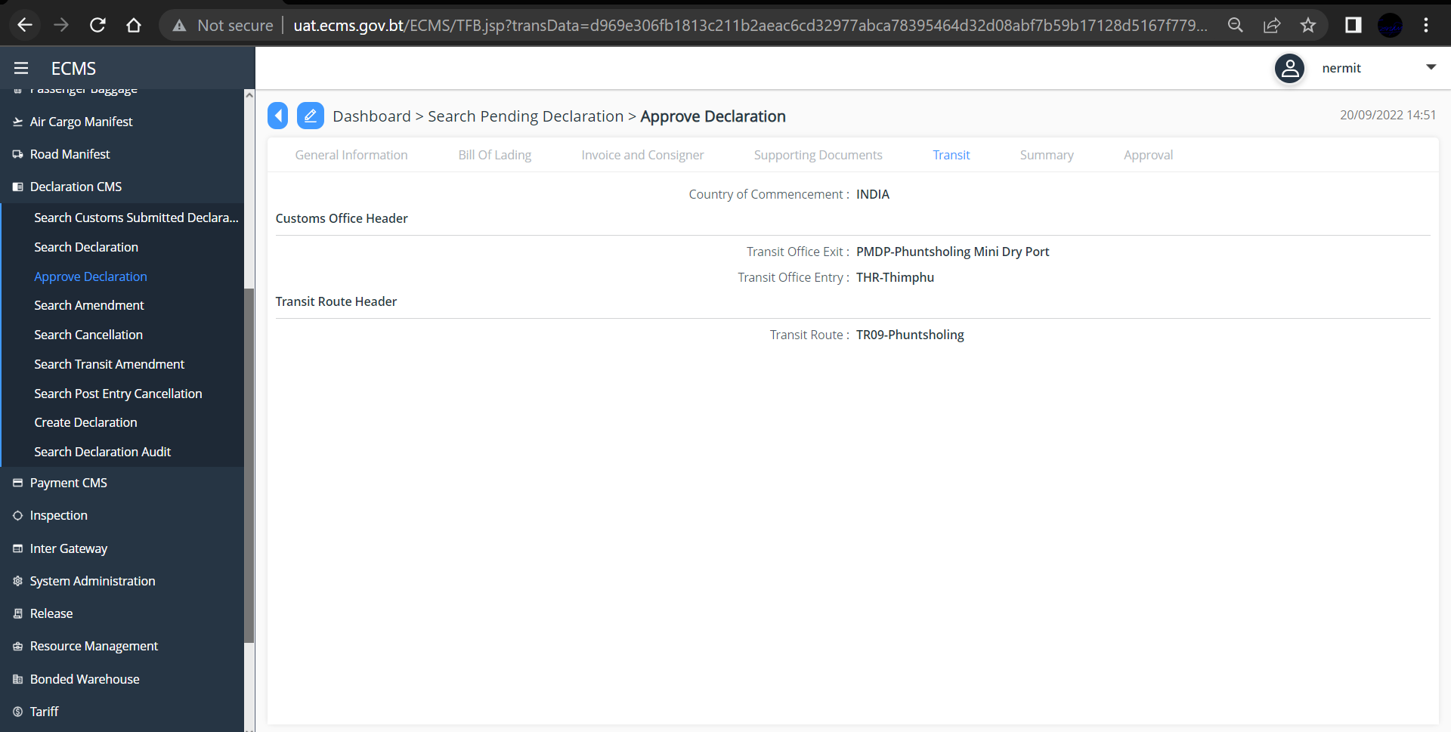

- Summary
Click Summary to view the summary of Declaration as below.
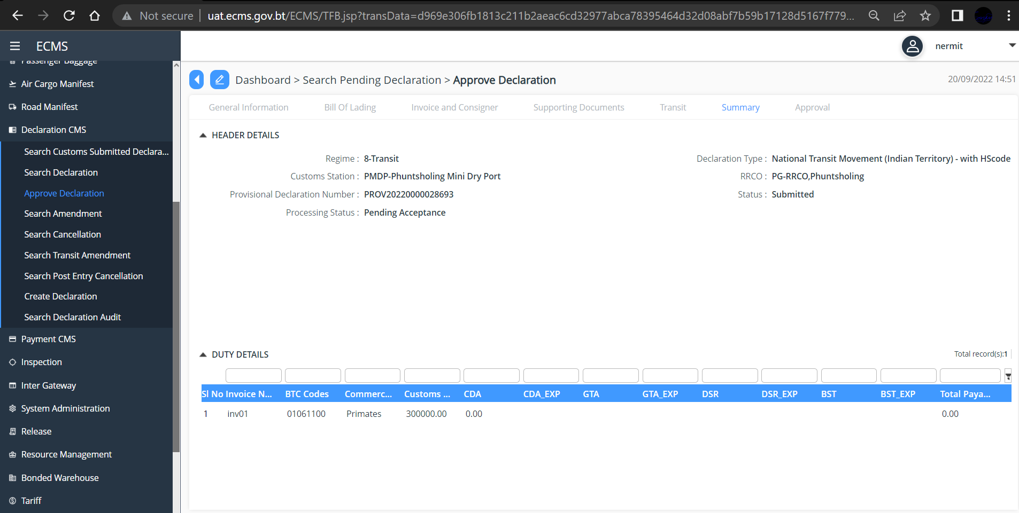

- Click>> Approval
Table item in Dropdown list consist of;

Field name | Drop down list | Description
*Status | Approved | Mandatory
 | Rejected
 | Rejected for Amendement
Remarks |  | Non-Mandatory

- From the dropdown list in the *Status Field” select your decision as “Approved”/” Rejected”/” Rejected for Amendment”.
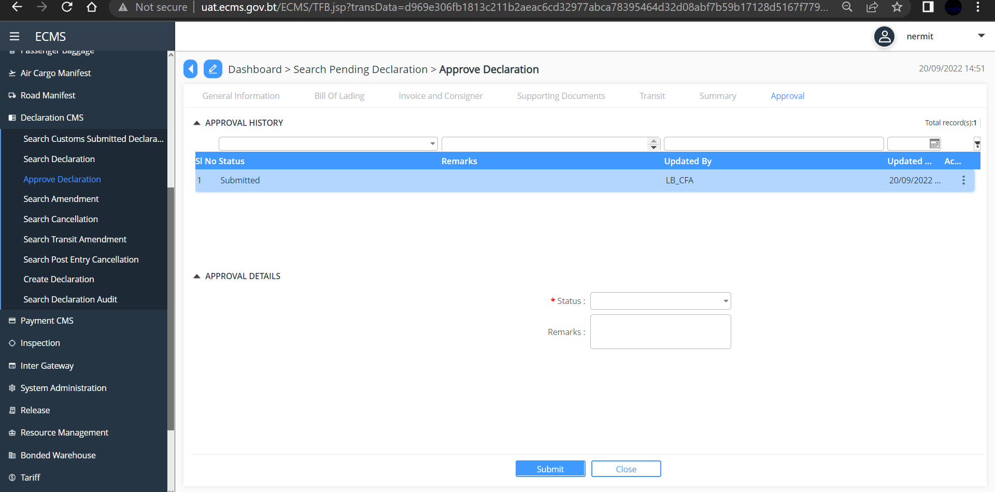
Fig.10. Approve Road Manifest

- Click >> “Submit”

Cantralized Risk
- Go to centralized risk in the menu and select “Pending Risk Assessment” subsequent screen is displayed.

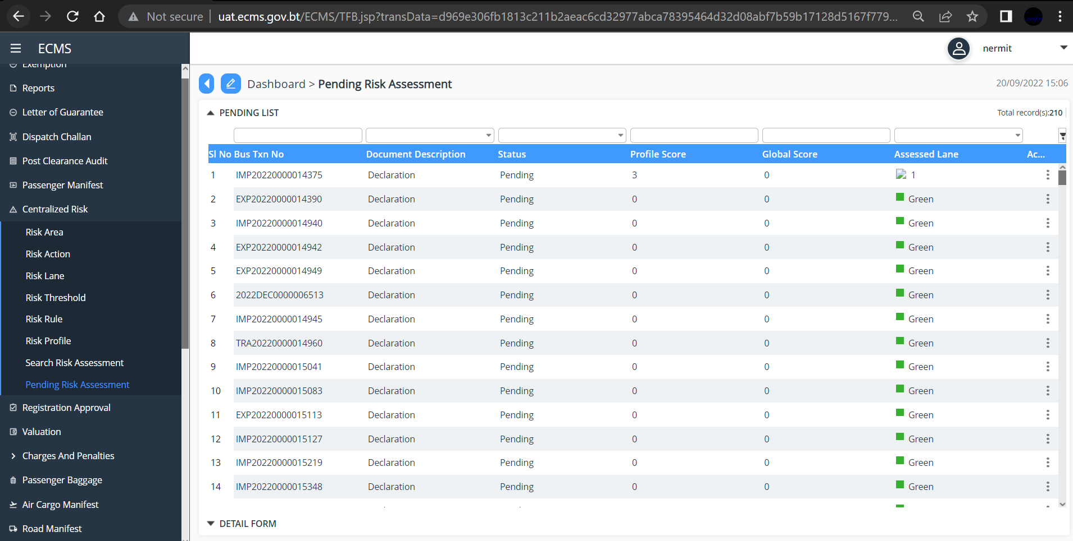
Fig. 11. Pending Risk List

- Click on the list to view OR you can view by clicking on the three dots available on the extreme right of each list and click view.

- Click “update” button.

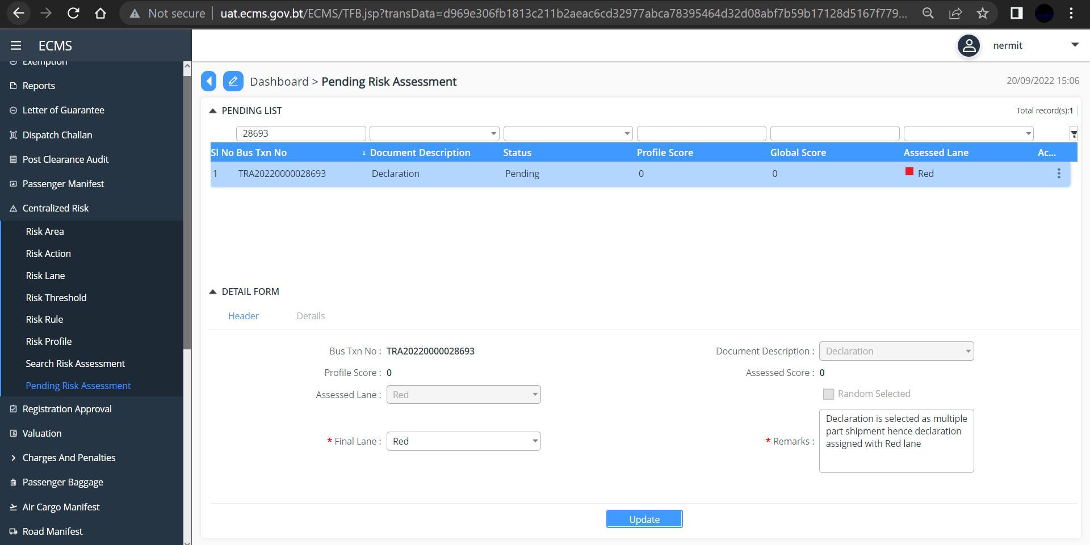
Fig. 12. Risk Assessment

Release Order
- Go to Release in the Menu and click on “Release Order”, Subsequent screen is displayed with pending release order list.

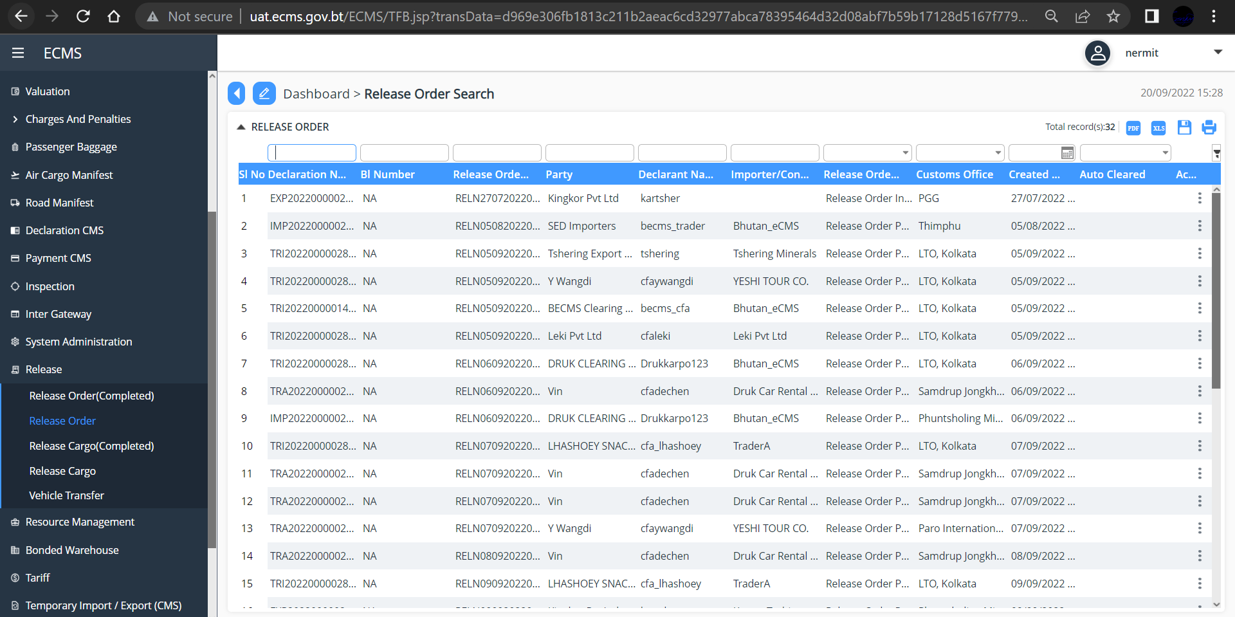

Fig. 14. Pending Release Order list

- Click on the list OR it can be view by clicking on the View button available under the three dots on extreme right of each list. Subsequent screen is displayed.

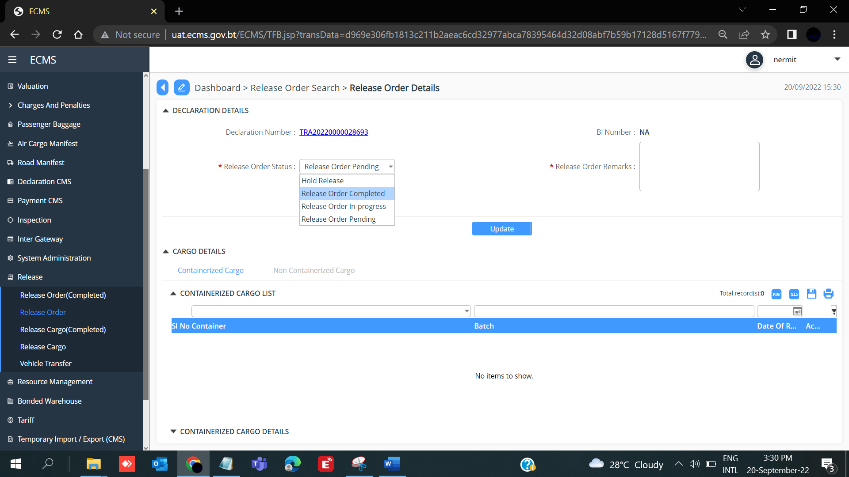
Fig. 15. View and Approve
- Update the Release Order Status, from the dropdown list
- Add Remarks
- Click “Update”

Release Cargo
- Go to Release in the Menu and click on “Release Cargo”, Subsequent screen is displayed with pending Release Cargo list.

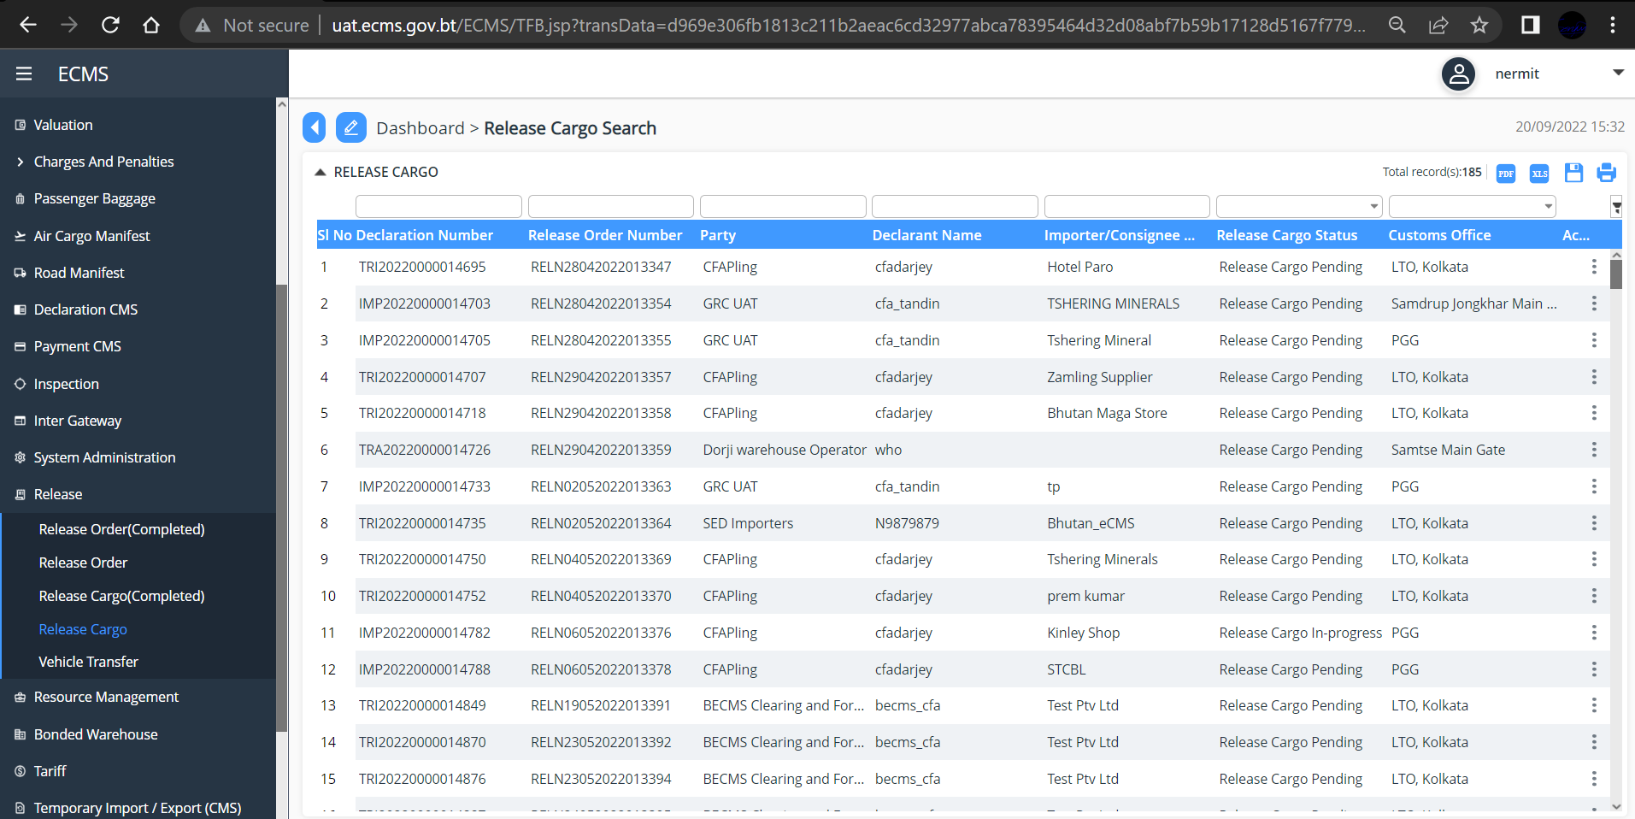

- Click on the list OR it can be view by clicking on the View button available under the three dots on extreme right of each list.
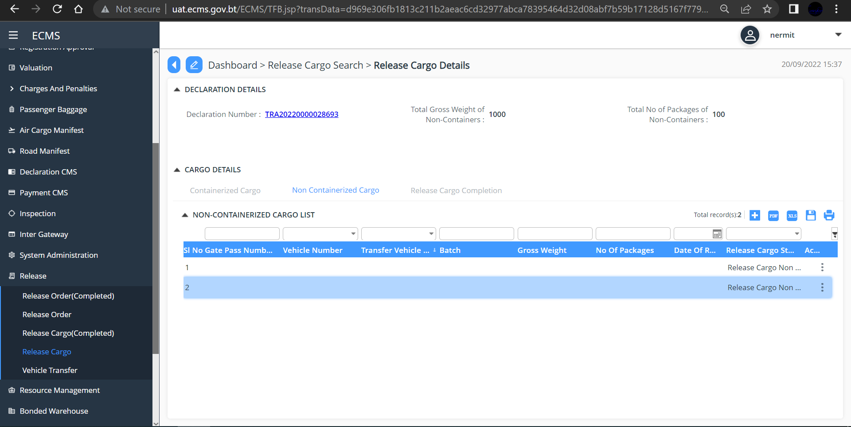

For part shipment, there are two NON-CONTAINERIZED CARGO LIST. In case for single shipment, there will be only one non-containerized cargo list.

- If your Cargo is non-Containerized, click on “Non-Containerized Cargo” Subsequent screen is displayed.
- Fill in all mandatory details
- Select and update the Status from “Release Cargo Status” drop down list.
- Click Update.
- Complete the Non-Containerized Cargo Detail for all the list

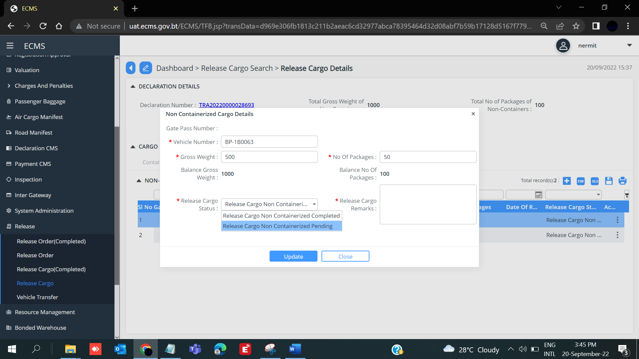

- Under “Release Cargo Completion” select decision from the “Release Cargo status” dropdown list as shown below.
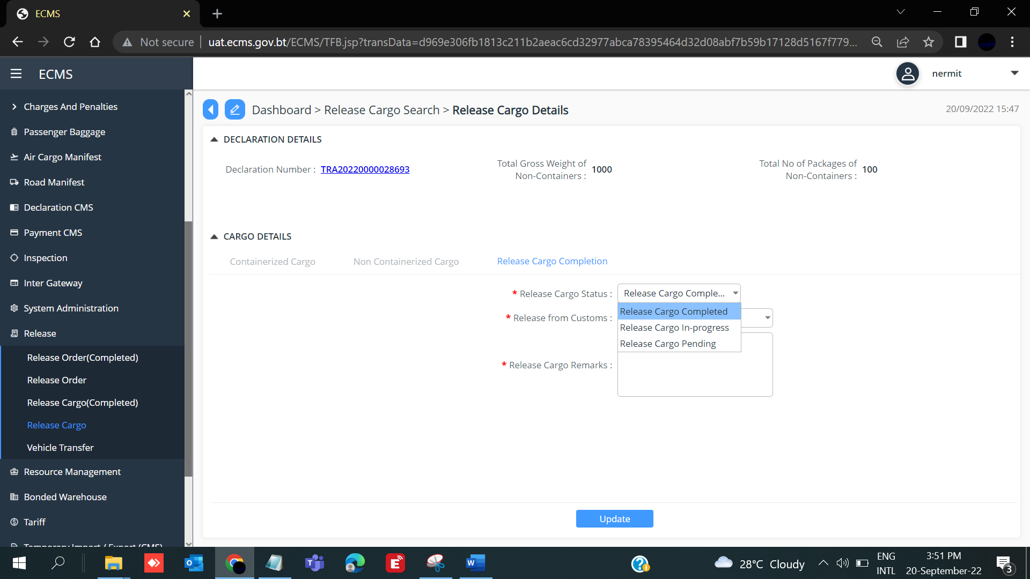

- Under “Release from Customs” select “YES” to release from custom.

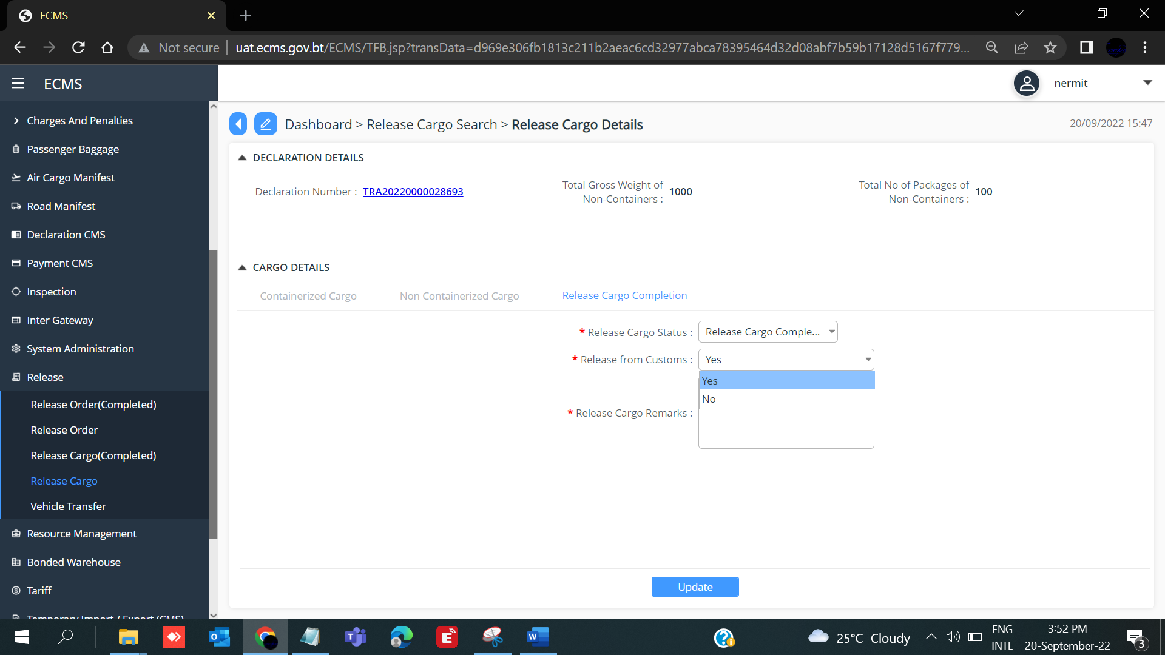

- Add Remarks under Remarks field
- Click “Update”

Inter Gateway

Port of Exit
- Go to Inter Gateway in the menu and select port of exit. Subsequent screen is displayed.
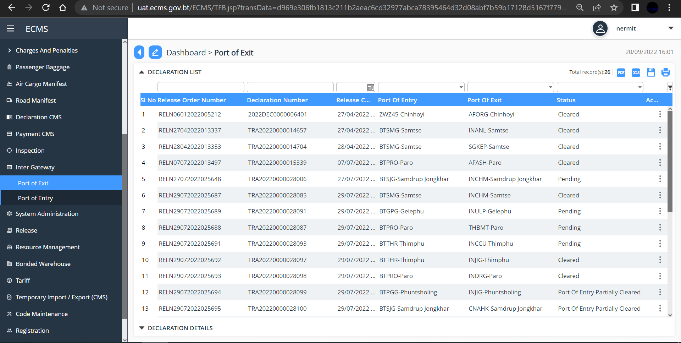

- Select the pending exit item by click on the item listed. Under the declaration detail, input the Serial number, Update the Status field from the dropdown list as shown below

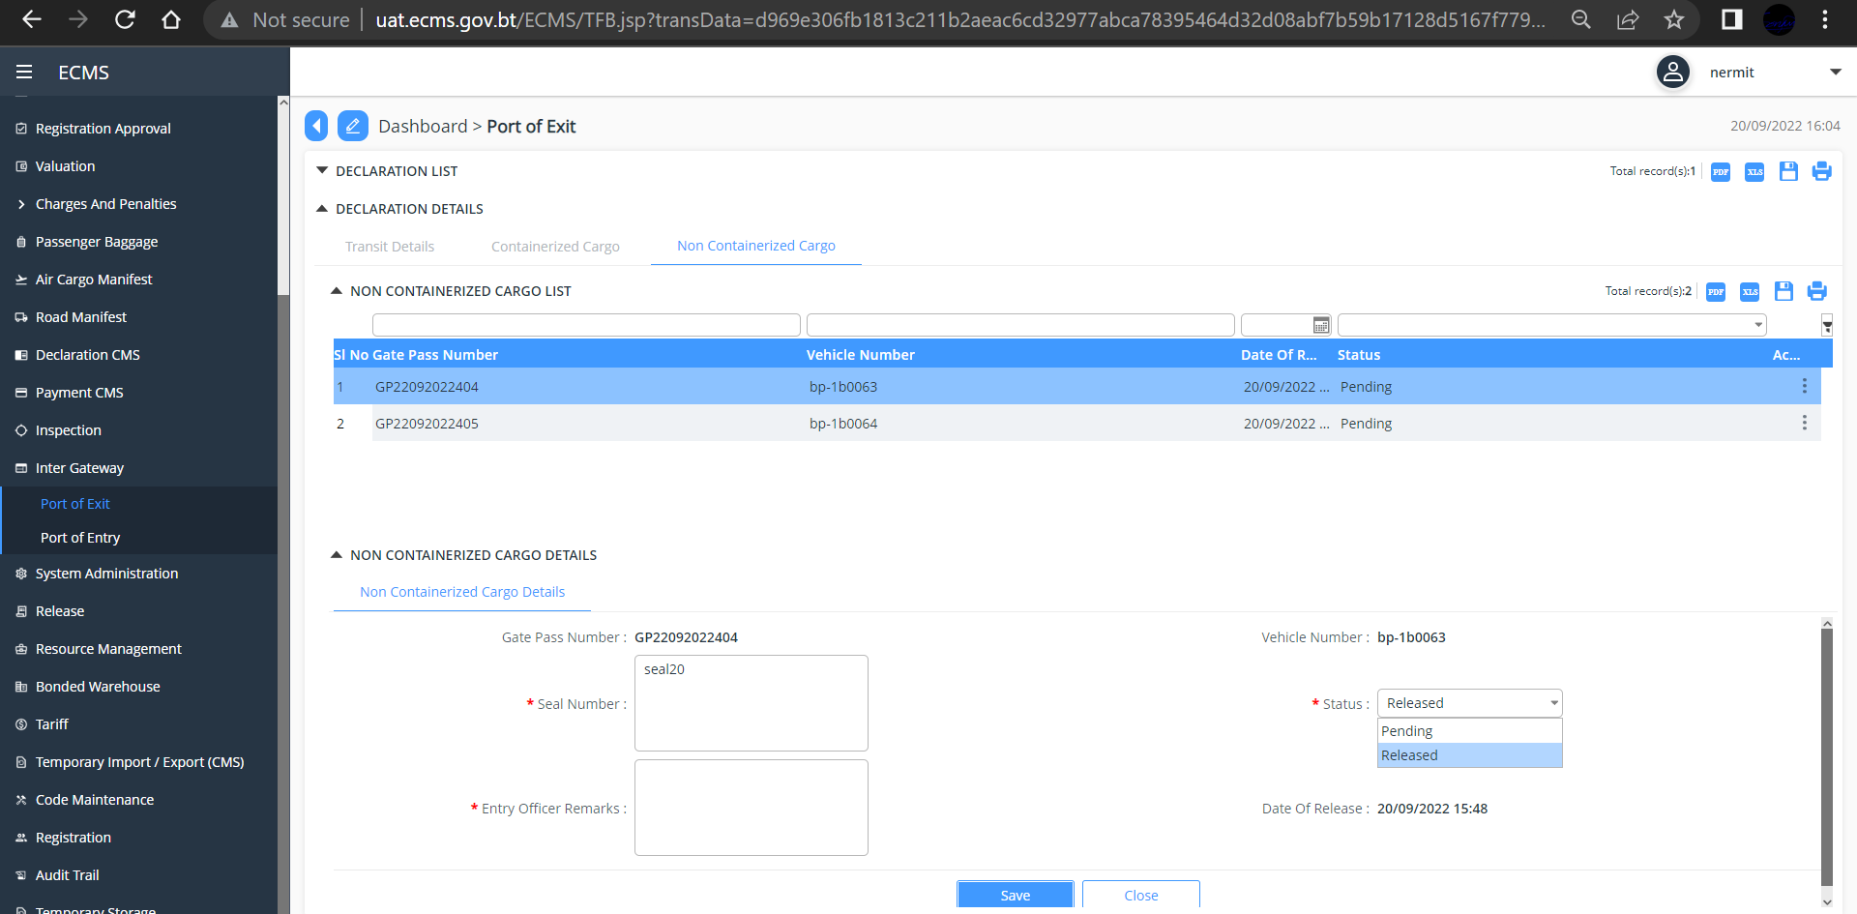

- Click “Save”

Port of Entry
- Go to Inter Gateway in the menu and select “Port of Entry”. Subsequent screen is displayed.

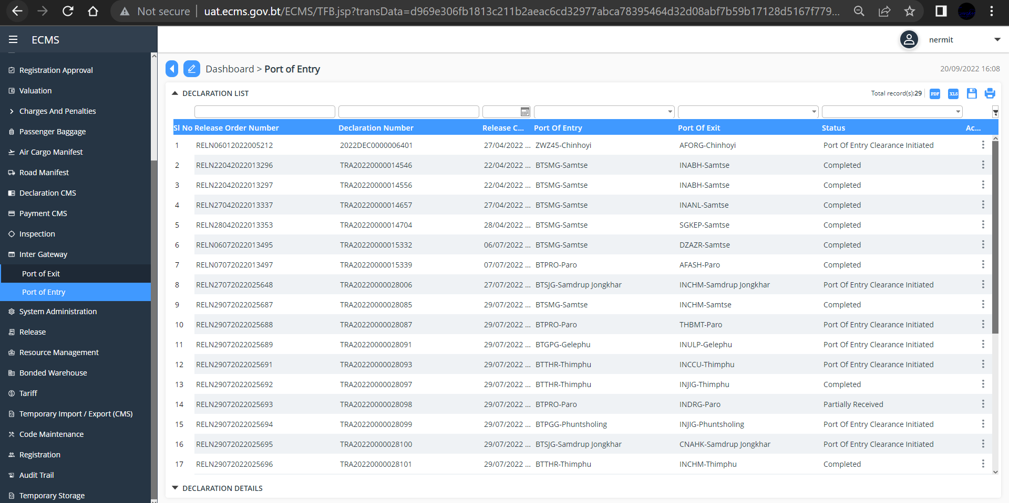

- Select the pending exit item by click on the item listed. Under the Declaration Details, click on the “Non-containerized Cargo” field to view the Cargo list.

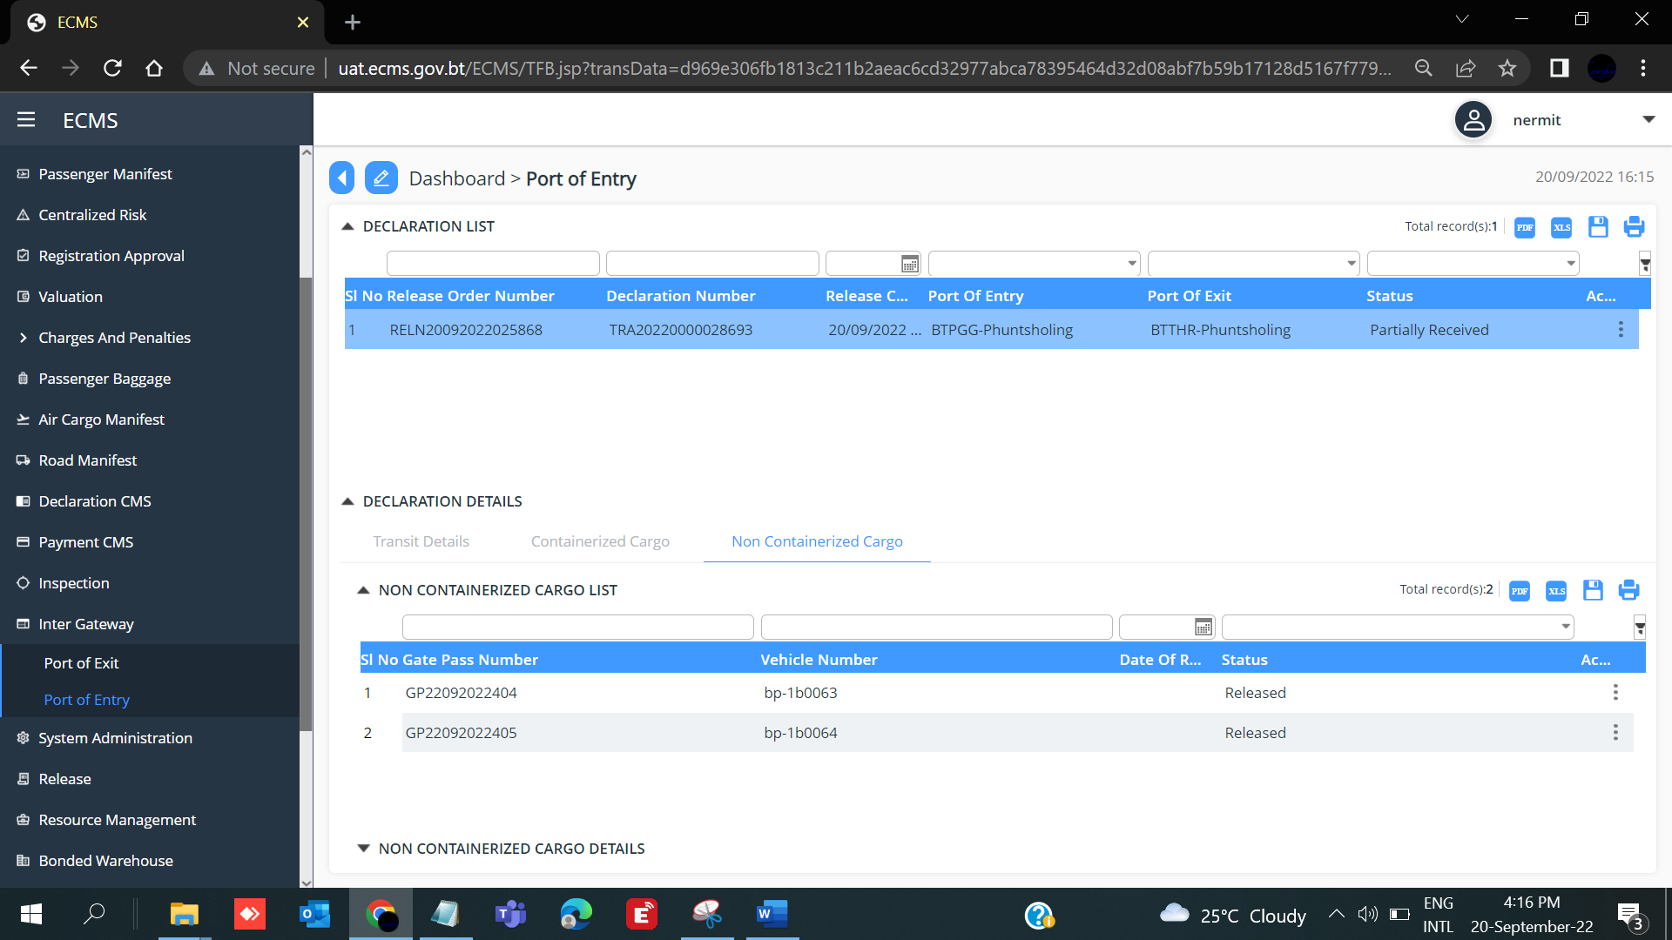

- Click on each item to view. Subsequent screen is displayed.
- In the *Status field, Change the status to “Received”
- Add Exit Remarks

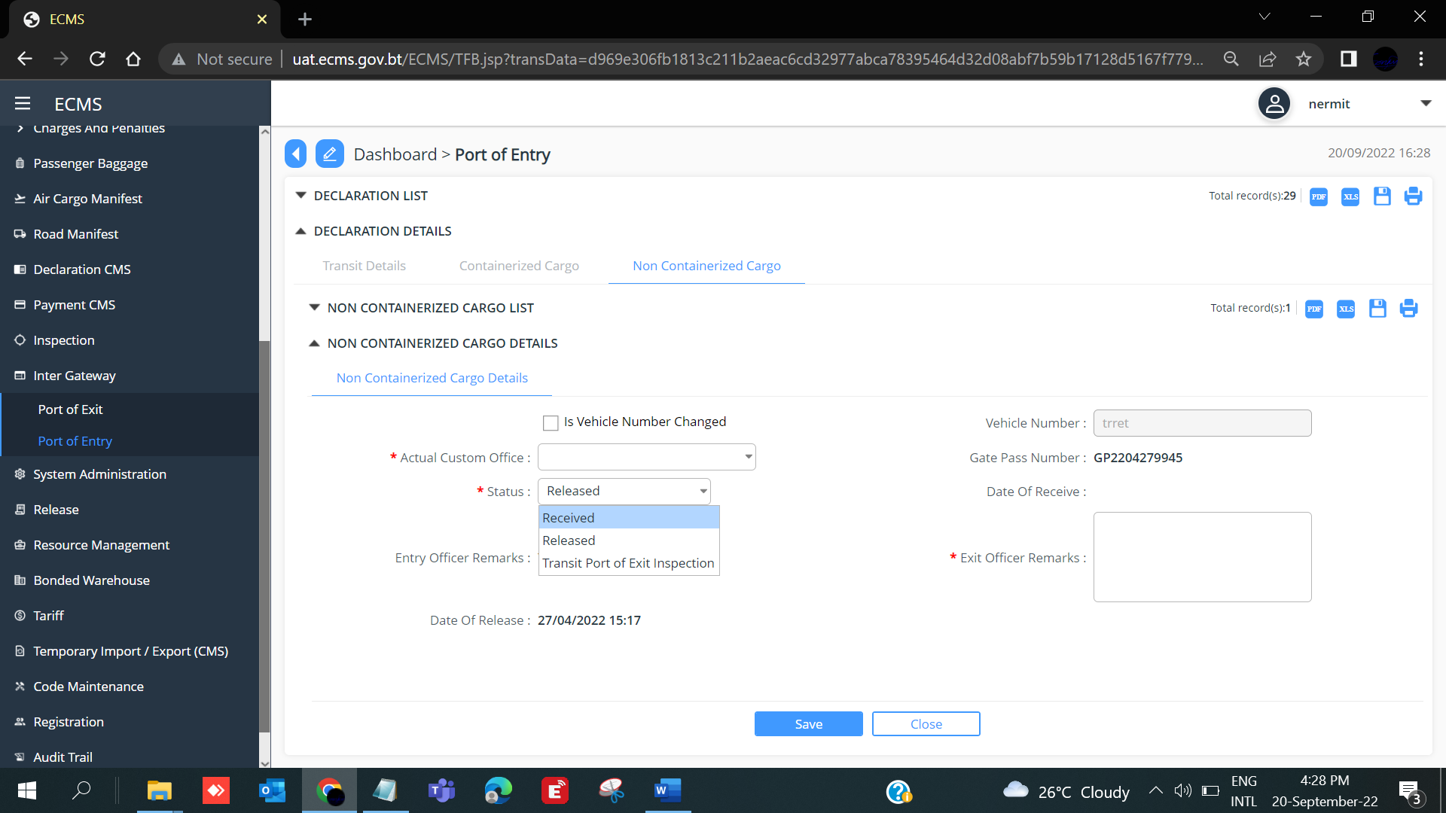

- Click “Save”

